# PROJECT PART 1



## CD STORE

## TEST DOCUMENT

### Prepared For:

Part1 CSI5380 Project Submission

### Submitted to:

Professor Dr. Hussein Al Osman

In partial fulfillment of the requirement for

CSI5380 - Systems and Architecture for Electronic Commerce

### Submitted by:

Web Builders

|  |  |  |  |
| --- | --- | --- | --- |
| Sl.No | Team Member | Student ID | Contact ID |
| 1 | Aishvarya Arul Nambi | 7758189 | aarul094@uottawa.ca |
| 2 | Indhra Priya Shanmugam | 7527045 | ishan050@uottawa.ca |
| 3 | Priyanka Patel | 7481432 | ppatel038@uottawa.ca |
| 4 | Rachana Chandrashekar | 7487187 | rchan092@uottawa.ca |
| 5 | Shruthi Madhurika Naomi | 7564806 | snaomi011@uottawa.ca |

# 1. Testing ProductCatalogWS

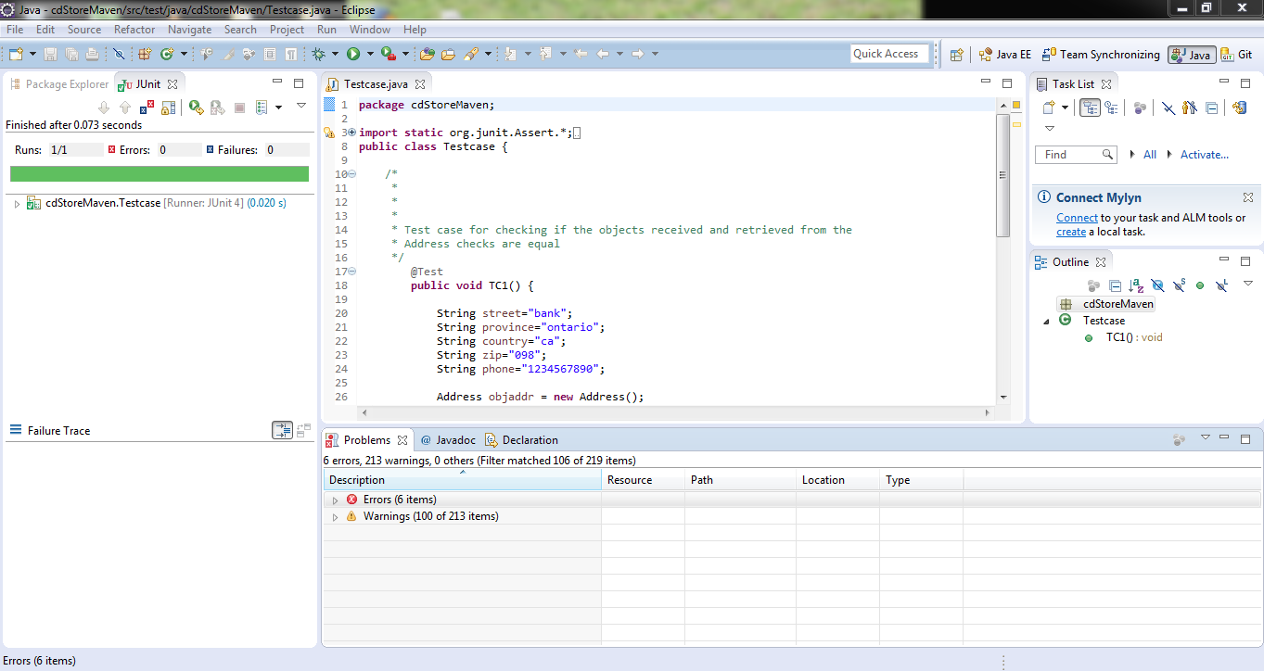

## Product Catalog actions etc.

# 2. Testing OrderProcessingWS

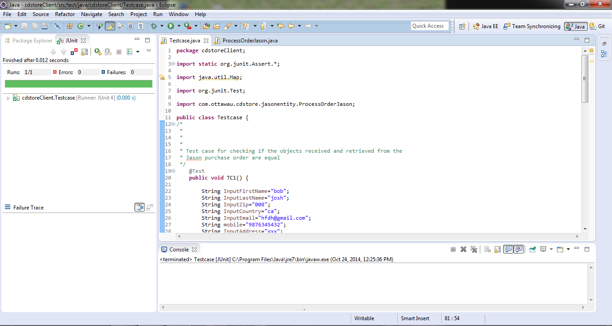

# 3. SessionController.CDStorePage

Test1: The CD Store's Main Page displaying all the Category lists on the left pane of the window and all the products of all the categories are shown in the center of the Main Page.

Test2: Products of selected categories are to be displayed successfully to the users.

**Scenario:** Let us consider that the user wishes to see the products that belong to Category 'POP'. The user should click on 'POP' from the Categories listed in the Main Page to view its products.

Test3: Detailed Product Information is to be displayed to the user when he/she wishes to know about the product before making a purchase.

## Scenario: Let us assume the user wishes to know the details of the product: 'Patsy Cline Im So Lonely' under the category: 'POP'. The user therefore, should click on the product of his choice. The user will be taken to the ProductInformation page which gives detailed information about the selected product. The page speaks about the Album description, Artist, Price offered by the store.

# 4. SessionController.ShoppingCart

Test1: Add products of choice to shopping cart

**Scenario1***:* Let us assume that the user read through the description of the product: 'Patsy Cline Im So Lonely' under the category: 'POP' and is interested in buying this product. The user is now expected to click on "Add to Shopping Cart" seen on the ProductInformation page to add his/her desired product to his/her shopping cart. This product addition has to be reflected on the shopping cart product counter. As seen below, the shopping cart now shows the number 1, which indicates that the user has added a product of his/her choice.

Test2: View products added into shopping cart.

At any point of time, the user should be able to view his/her shopping cart items.

**Scenario1:**The user has not added any product into his/her shopping cart. When the user attempts to view his/her shopping cart, the GUI displays suitable user understandable message as seen below.

**Scenario2:**When the user has added 1 or more products of his/her choice to his/her shopping cart, then the user should be displayed his/her added products in the shopping cart as below.

Test3: Remove products from the shopping cart.

At any point of time, the user should be able to delete the product, that he/she has previously added into the shopping cart.

**Scenario1:**The user has now added two products into his/her shopping cart: *Product1: Patsy Cline Im So Lonely* and *Product2: Johnny Cash Greatest Hits*. Before placing the order, the user decides to remove one of the previously added products, say, *Product1: Patsy Cline Im So Lonely.* To delete this product of his/her choice, the user is expected to click on "Delete" button located next to that particular product as shown below:

Test4: Edit quantity for the selected product in the shopping cart.

**Scenario1:**The user has now added two products into his/her shopping cart: *Product1: Patsy Cline Im So Lonely* and *Product2: Johnny Cash Greatest Hits*. Before placing the order, the user decides to buy 2 of similar product, say, *Quantity=2* for the *Product1: Patsy Cline Im So Lonely*. The user has to manually change the quantity from 1 to 2 against the product of his choice. The user is required to change the quantity of the desired products before the checkout operation, otherwise if the user continues shopping after changing the quantity, the user will be prompted with a message that the changed quantity will be lost and thus the loss of quantity change and user is taken back to Home Page.

# 5. SessionController.Account Order

Test1: User prompted for login information when he proceeds with checkout activity

The user can either login if he already has an account created. Else, the user is required to create a new account before he/she proceeds with order processing action.

**Scenario1:**The user has now added products of his/her choice and would wish to place an order on the selected product items. The user is required to click on "Proceed to CheckOut" button from the

Test2: User creates new account

**Scenario1:**Let us assume, the user is a new user and has no account created previously. So, the user now proceeds with creation of an account. The user clicks on "create an account" seen under "Not a Registered User" section and fills in the registration form and submits the same on which the form is suitably validated and user account is created. The user after login, is taken to the home page. However, the shopping cart items remain unchanged.

Test3: User logs into an existing account

**Scenario1 :** Let us assume, the user is an old user who has once created an account during his last purchase from the store. This user can proceed providing his/her login credentials on which he/she is taken to the home page and the added items in the shopping cart remain unchanged.

Test4: Provide Credit card details without modifying Shipping Address

**Scenario1:**Let us assume, the user has successfully logged into the account and wishes to proceed with the checkout. He/She is expected to click on "Proceed to CheckOut" to enter shipping and orderdetails page. The user is displayed with his/her order details(quoting the OrderID and Total Price).The user having not to change the Shipping Address can fill in the Credit Card details and click on "Confirm Payment" button to make payment, on which he is navigated to the orderconfirm page.

On clicking "Confirm Order" without filling in the credit card details, the user is alerted with suitable message as below.

On clicking "Confirm Order" after the user fills in credit card details validly.

Test5: Provide Credit card details after modifying Shipping Address

**Scenario1:**Let us assume, the user has successfully logged into the account and wishes to proceed with the checkout. He/She is expected to click on "Proceed to CheckOut" to enter shipping and orderdetails page. The user can click on "Modify Shipping Address" button to change the shipping address. However, if the user decides not to change the shipping address, the new shipping form fields disappear on re-clicking on "Modify Shipping Address" button.

# 8. Sample Test Scenarios and TestCases

The table below illustrates the test scenarios. The test team came up with the possible test cases satisfying all the possible test scenarios. Subset of the test scenarios and related cases are recorded in the following table.

|  |  |  |  |
| --- | --- | --- | --- |
| **Sl.No** | **Test Scenario** | **Related Test Cases** | **Result** |
| 1 | Verify the GUI screens | **CD Store URL:**  Verify that the link is unbroken and the user is successfully seeing the home page when he/she types the right URL in the browser. | **Success** |
| **CD Store Main page:**  Verify that the Main page is loaded successfully on providing the right URL.  Verify that the Main page displays the categories successfully on the left sidebar and the user can navigate to any of the displayed category page to view the related CDs.  Also verify that the Main Page displays all the products of all the categories | **Success** |
| 2 | Product Information | **The user should be successfully taken to the product information page on clicking the product of interest:**  Verify that the user is shown all the related information of the product in this page. The information like band description, band picture, band artists and product cost are shown in this page. | **Success** |
| 3 | Shopping Cart | **The user should be able to add products into shopping cart:**  The user should be allowed to modify the quantity of the products in the shopping cart before confirming order.  The user should be allowed to view his/her cart at any point of time.  The user should also be allowed to delete the cart items at any point of time. | **Success** |
| 4 | Shipping Address | **Shipping order to the same address provided during Registration:**  The user is prompted to confirm the shipping address before he proceeds with the payment.  The user can have the selected products shipped to his own address which is recorded in the DB table during the user account creation.  This is the address shown for verification on the Confirm Shipping Address page.  By clicking on "Ship to this address!", the user is selecting his residing address as the shipping address and is then taken to the credit card payment section successfully. | **Success** |
| **Shipping order to the address different from his/her residing address:**  The user can have the selected products shipped to different address, other than his residing address.  In that case, the user has to click on "No, Not here!" button in the "Confirm Shipping Address" page.  The user is then taken to "Change Shipping Address" page, where he/she has to fill in the new address form.  On filling the Shipping Address form, the user has to click on "Proceed!" button to proceed with credit card payment. | **Success** |
| 5 | Credit Card Information | The user is navigated to "CreditCardDetails" page, where he/she can make payment for his/her orders through credit card.  The user has to enter Card holder's first name, last name, credit card number and its expiration date(in the format: mmyy) and click on "Submit Payment" button.  It is necessary to provide Card ID/CCV2 if the card type is American Express/Visa/MasterCard.  ***Note:***  *American Express: 4 digits on the front of the card.*  *Visa/MasterCard: Last 3 digits on the back of the card.*  The user will be successfully taken to "Confirm Order" page on clicking the "Submit" button, after filling in the required fields on CreditCardDetails page. | **Success** |
| 6 | Confirm Order Processing | **Order confirmation:**  After the user has made the payment for his order, he is displayed an “Order Confirmation” message, if the payment is successful. Else, the user is displayed with suitable error messages. | **Success** |
| 7 | Reject 5th request | **The user should be rejected for every multiple of 5th tries.** | **Success** |